**Hasil Perbandingan Sentimen Shopee dengan Lazada**

1. Subjective polarity analys

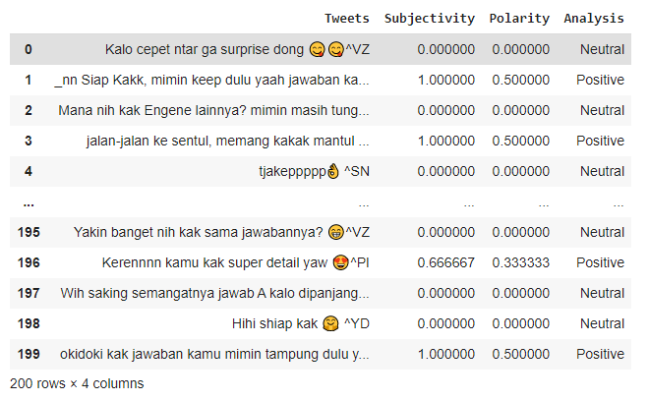

Gambar Shopee

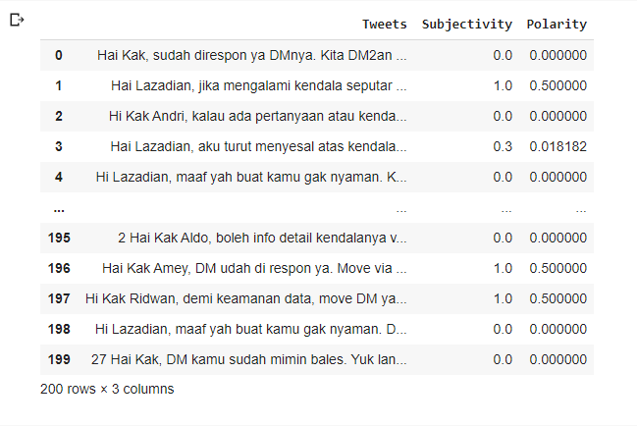

Gambar Lazada

1. Sentimen Analys

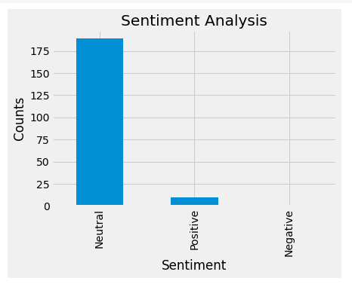

Gambar Shopee

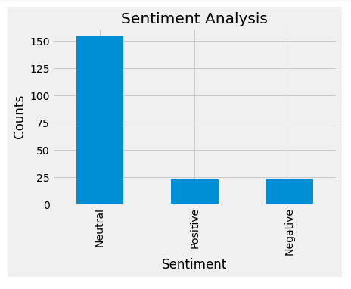

Gambar Lazada